

**EduBridge Learning Pvt.Ltd**

Center: Trichy

A Main Project Report

On

**E-Commerce Application**

**PRESENTED BY**

Santhiya M

Kowsalya Elumalai

Nithiyanantham Manikandan

Harathi MB

Palanikumar A

Batch Code: 2022-7457

**Guidance byTrainer: Yogesh Gopal Jangle**

**(**EduBridge Learning Pvt.Ltd**)**

## Introduction:

E-commerce (electronic commerce) is the buying and selling of goods and services, or the transmitting of funds or data, over an electronic network, primarily the internet. These business transactions occur either as business-to-business (B2B), business-to-consumer (B2C), consumer-to-consumer or consumer-to-business. E-commerce web-page can be accessed throughout the customers with proper login provided.

**Main Modules:-**

* Admin Module
* User Module
* Register Module
* Index Module

I have developed this Application in **Java, JSP, Servlets, Hibernate and MySQL.** It’s a web-based projects so I have used **HTML, CSS, JavaScript and Bootstrap**.

The primary goal of e-commerce is **to reach maximum customers at the right time to increase sales and profitability of the business**. Functions of e-commerce include buying and selling goods, transmitting funds or data over the internet.

The main objective of the E-Commerce is to reduce manual work and time. It is difficult and time-consuming to collect all the details from each customer. To avoid this problem, we have planned to develop a web-based E-Commerce system. In Admin module, admin can add the Category and Products in the specific category. He can also view the total number of users at present in the website, category and product details also. Admin can only see the admin page and cart if he wants to order something.

**The Seven Features of eCommerce**

* Provide Ubiquity to Increase Sales
* Strike an Information
* Density Balance
* Ensure Global Reach and Security
* Have Universal Standards
* Don't Skimp on Richness
* Think About Interactivity

**Advantages of ecommerce web-site**

* Faster buying process
* Store and product listing creation
* Cost reduction
* Product and price comparison
* Faster response to buyer/market demands
* Affordable advertising and marketing
* Flexibility for customers
* No reach limitations.

**Admin Module:** Admin can able to handle User portal and Registration portal. It provides access to the User for uploading new product as well as to track the order of product with a username and password.

**User Module:** Recruiter can access this website by signing up. User can search for the product, access to save it for later, monitoring their order and Payments.

**Register Module:**In this module a new user cansigning up using their Username, Email ID, password and their address.

**Index Module:** In this Module the user can view the name, price and rating for the products. And have access to buy the product. Also, having the customer supports and can view the best deal of the day.

**Software Requirements:**

**Front end:** Java/J2EE technologies (Servlet, JSP), HTML, CSS,

JavaScript, Bootstrap and Hibernate.

**Back end**: MySQL workbench.

**Middleware/Server:** Apache Tomcat v8.5. IDE: Spring tool suite for Java EE Developers

**Browser:** Google Chrome

**Operating System:** Windows

# **Data Dictionary:**

* **Create Database shoppingdb;**

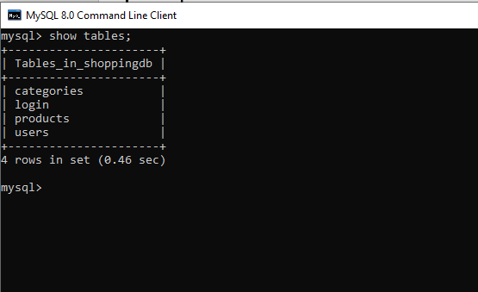

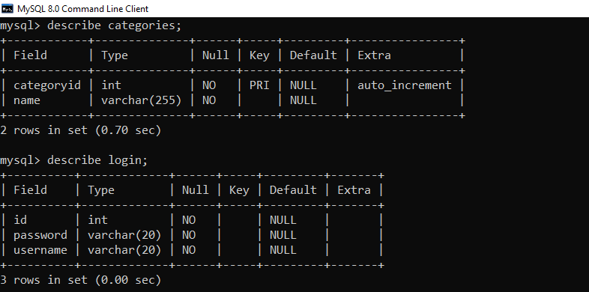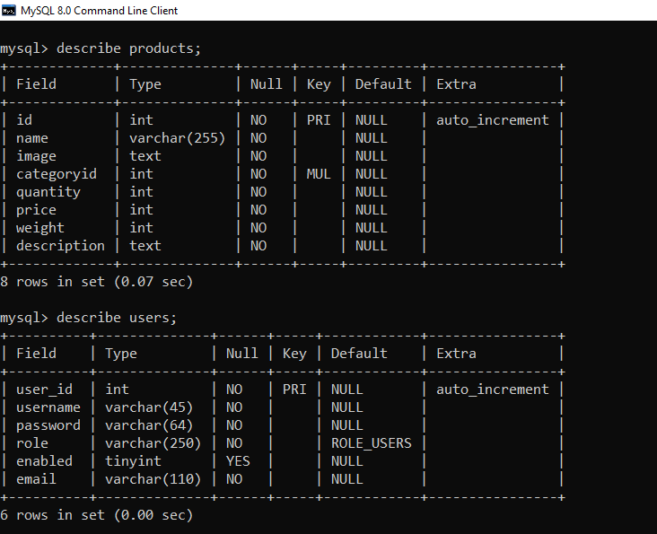

# **Screenshots:-**

## Home Page:

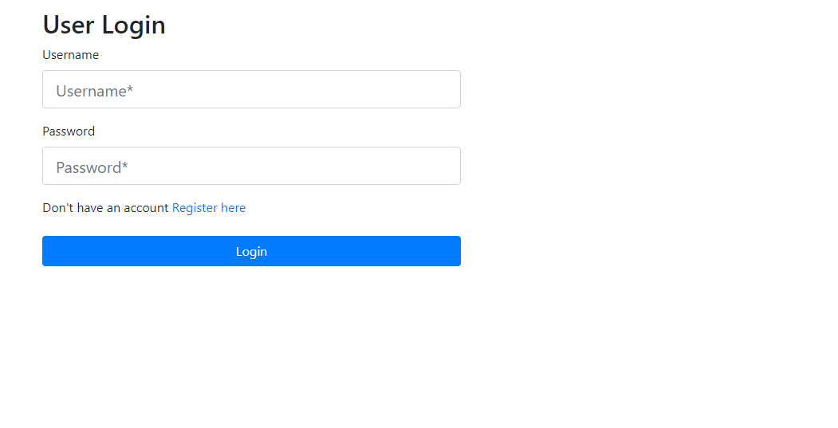

**Admin Page:**

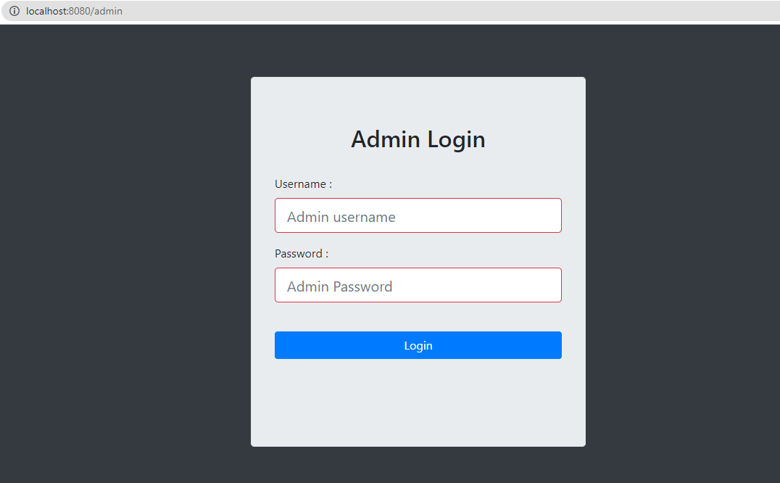

**New Registration page:**

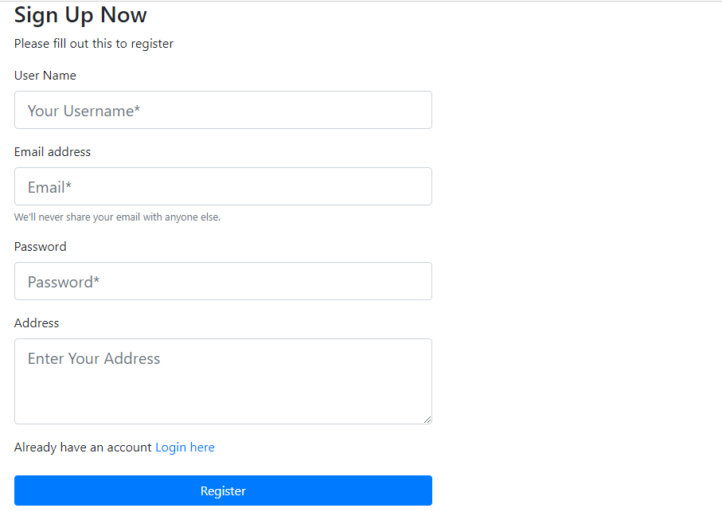

**User Index:**

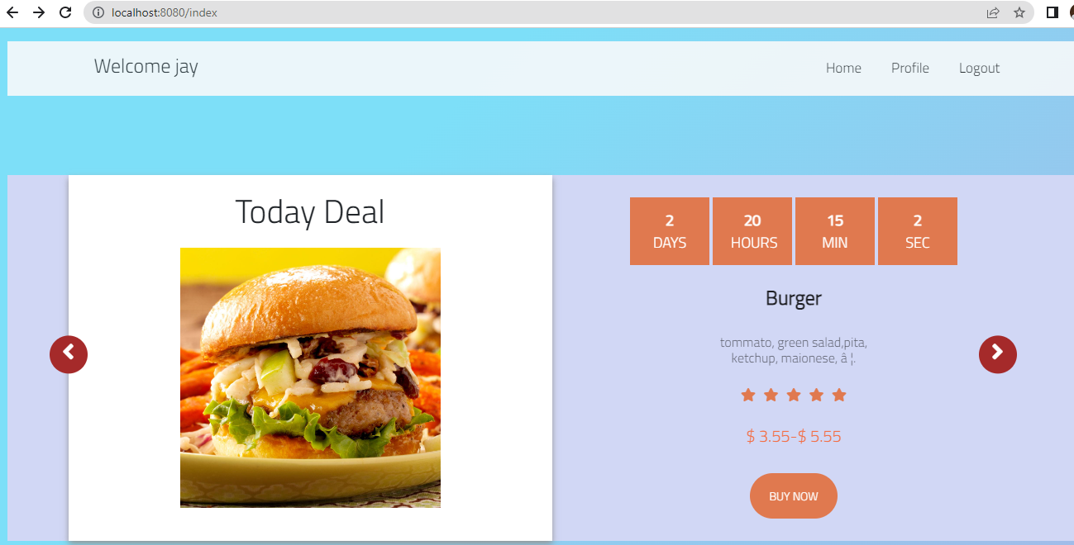

**User Profile Page:**

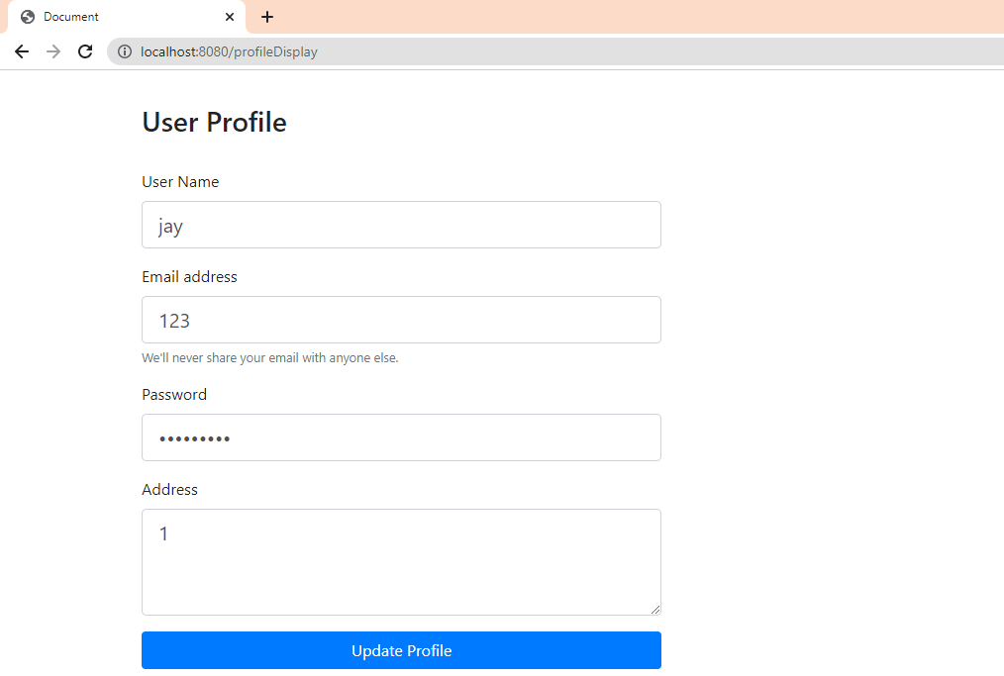

**User Support Page:**

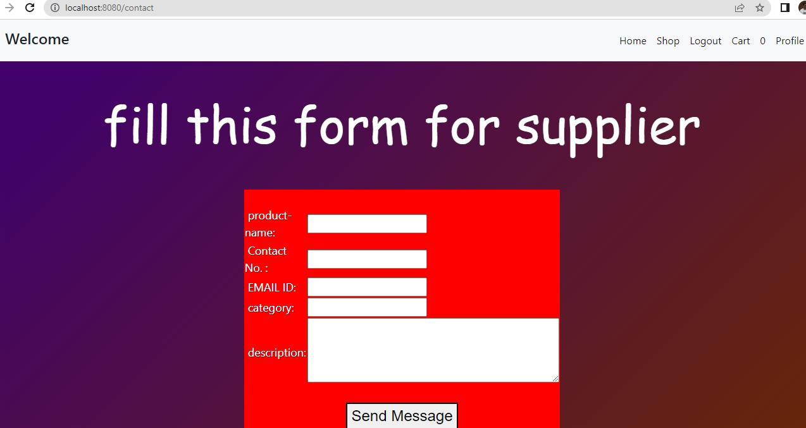

**Admin Home Page:**

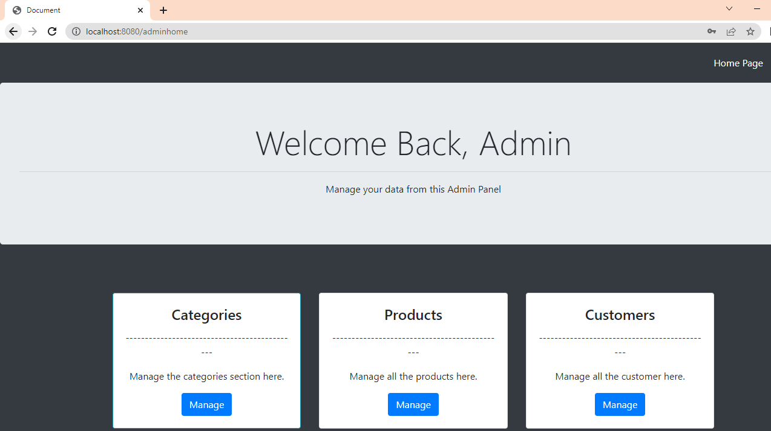**Categories page:**

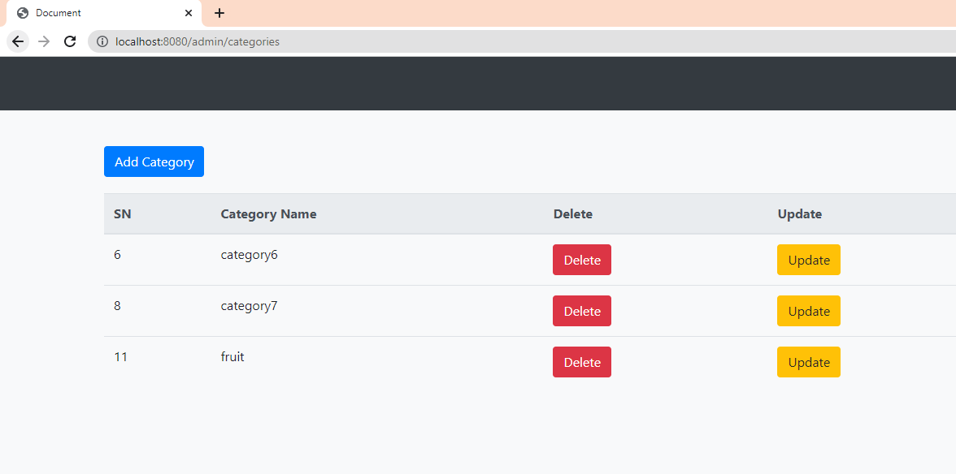

**Add Product page:**

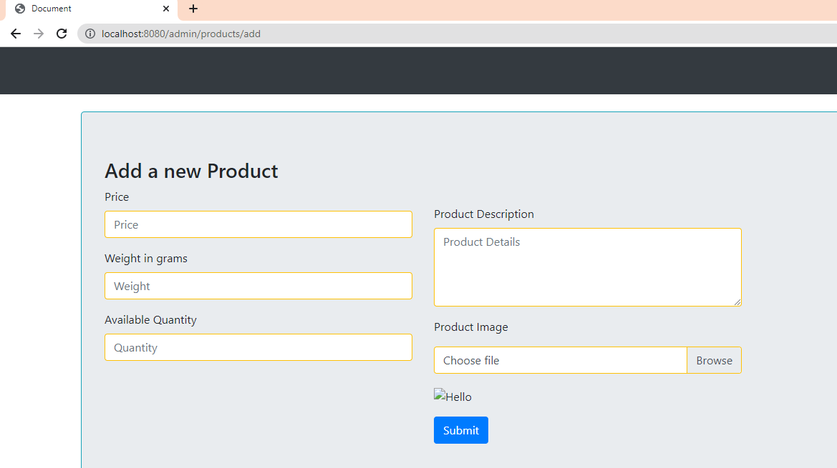

**THANK YOU.**